**Template Issues**

**Super Admin**

* In user profile section when click on any section’s edit button it opens irrelevant modal except personal information.

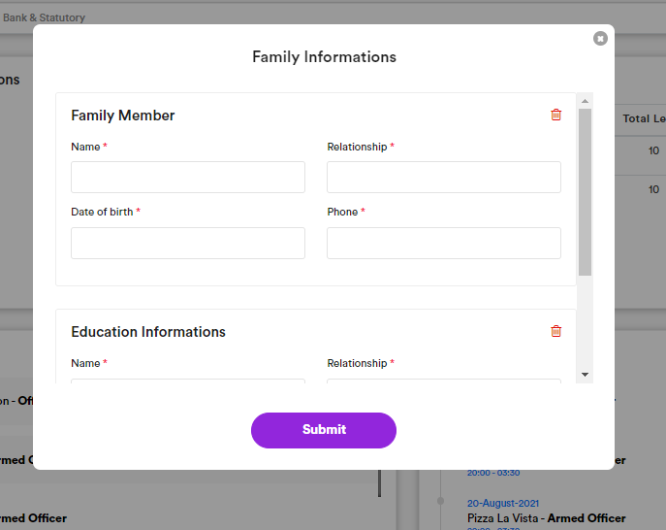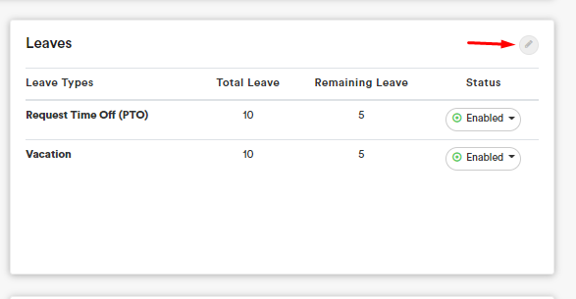

* Search in header redirects to search.html which is missing in template.

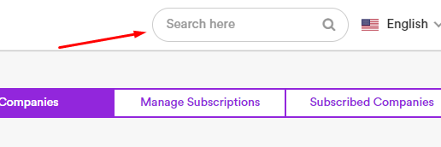

* Clients and companies are same?

